Tela de Inserção de Carro

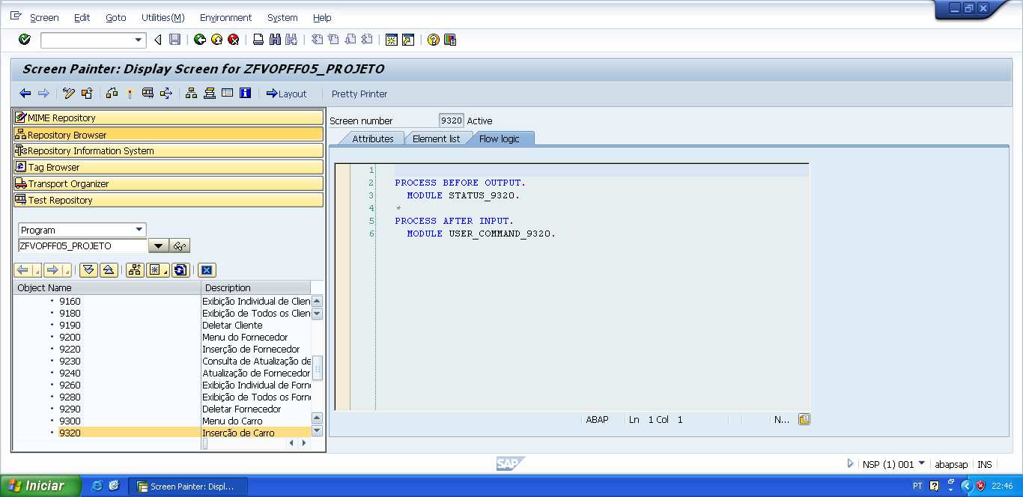

PROCESS BEFORE OUTPUT.  
  MODULE STATUS_9320.

*&---------------------------------------------------------------------*  
*&      Module  STATUS_9320  OUTPUT  
*&---------------------------------------------------------------------*  
*       text  
*----------------------------------------------------------------------*  
MODULE status_9320 OUTPUT.  
  SET PF-STATUS 'STATUS9320'.  
  SET TITLEBAR 'TITULO320'.  
  
ENDMODULE.                 " STATUS_9320  OUTPUT

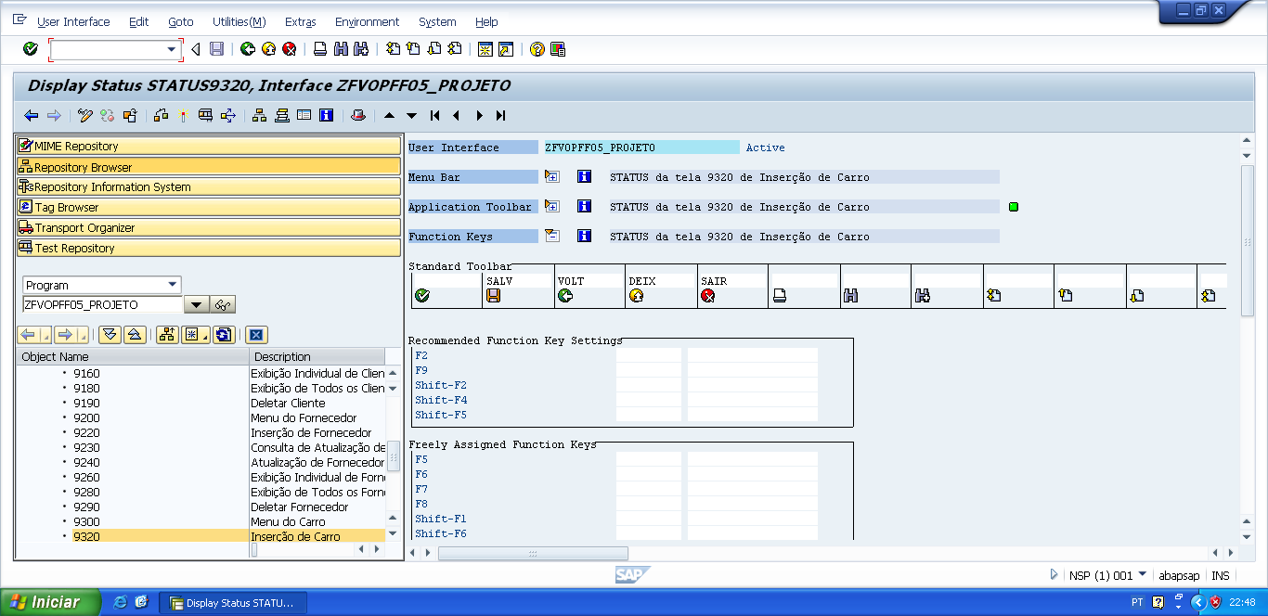

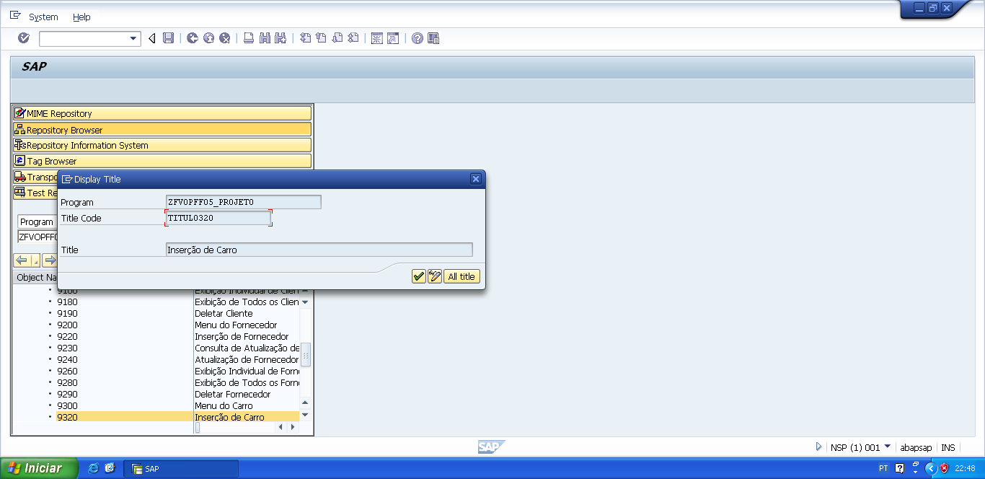

PROCESS AFTER INPUT.  
   MODULE USER_COMMAND_9320.

*&---------------------------------------------------------------------*  
*&      Module  USER_COMMAND_9320  INPUT  
*&---------------------------------------------------------------------*  
*       text  
*----------------------------------------------------------------------*  
MODULE user_command_9320 INPUT.  
  
  v_okcode = sy-ucomm.  
  
  CASE v_okcode.  
    WHEN 'VOLT'.  
      PERFORM f_voltar.  
    WHEN 'DEIX'.  
      PERFORM f_deixar.  
    WHEN 'SAIR'.  
      PERFORM f_sair.  
    WHEN 'SALV'.  
      PERFORM f_salvar_carro.  
*  
    WHEN 'SAC2'.  
      PERFORM f_salvar_carro.  
  ENDCASE.  
  
  CLEAR v_okcode.  
ENDMODULE.                 " USER_COMMAND_9320  INPUT

*&---------------------------------------------------------------------*  
*&      Form  F_VOLTAR  
*&---------------------------------------------------------------------*  
* FORM de voltar, serve para voltar automaticamente para a tela  
*anterior da tela atual.  
*----------------------------------------------------------------------*  
*  -->  p1        text  
*  <--  p2        text  
*----------------------------------------------------------------------*  
FORM f_voltar.  
  
*Volte para á tela 9000 (Tela Principal)  
*ou  
**CALL SCREEN '9000'.**  
  PERFORM f_limpar_variaveis.  
  SET SCREEN 0.  
  LEAVE SCREEN.  
  
  
ENDFORM.                    " F_VOLTAR  
  
*&---------------------------------------------------------------------*  
*&      Form  F_DEIXAR  
*&---------------------------------------------------------------------*  
*       text  
*----------------------------------------------------------------------*  
*  -->  p1        text  
*  <--  p2        text  
*----------------------------------------------------------------------*  
FORM f_deixar .  
  
  LEAVE LIST-PROCESSING.  
  
ENDFORM.                    " F_DEIXAR  
  
*&---------------------------------------------------------------------*  
*&      Form  F_SAIR  
*&---------------------------------------------------------------------*  
*       text  
*----------------------------------------------------------------------*  
*  -->  p1        text  
*  <--  p2        text  
*----------------------------------------------------------------------*  
FORM f_sair.  
  
  LEAVE LIST-PROCESSING.  
  
ENDFORM.                    " F_SAIR

*&---------------------------------------------------------------------*  
*&      Form  F_SALVAR_CARRO  
*&---------------------------------------------------------------------*  
*       text  
*----------------------------------------------------------------------*  
*  -->  p1        text  
*  <--  p2        text  
*----------------------------------------------------------------------*  
FORM f_salvar_carro .  
  
  DATA: lwa_zfvtpff05_carro TYPE zfvtpff05_carro.  
  
  lwa_zfvtpff05_carro-chassi_carro      = v_chassi_car.  
  lwa_zfvtpff05_carro-ano_carro         = v_ano_car.  
  lwa_zfvtpff05_carro-modelo_carro      = v_modelo_car.  
  lwa_zfvtpff05_carro-cor_carro         = v_cor_car.  
  lwa_zfvtpff05_carro-cnpj_fornecedor   = v_cnpj_forn.  
  lwa_zfvtpff05_carro-cpf_cliente       = v_cpf_cli.  
  
  
  INSERT zfvtpff05_carro FROM lwa_zfvtpff05_carro.  
  
  IF sy-subrc IS INITIAL.  
  
    MESSAGE s003(zfvclpff05).  
    PERFORM f_limpar_variaveis.  
  
  ELSE.  
  
    MESSAGE s004(zfvclpff05) DISPLAY LIKE 'E'.  
  
  ENDIF.  
  
ENDFORM.                    " F_SALVAR_CARRO